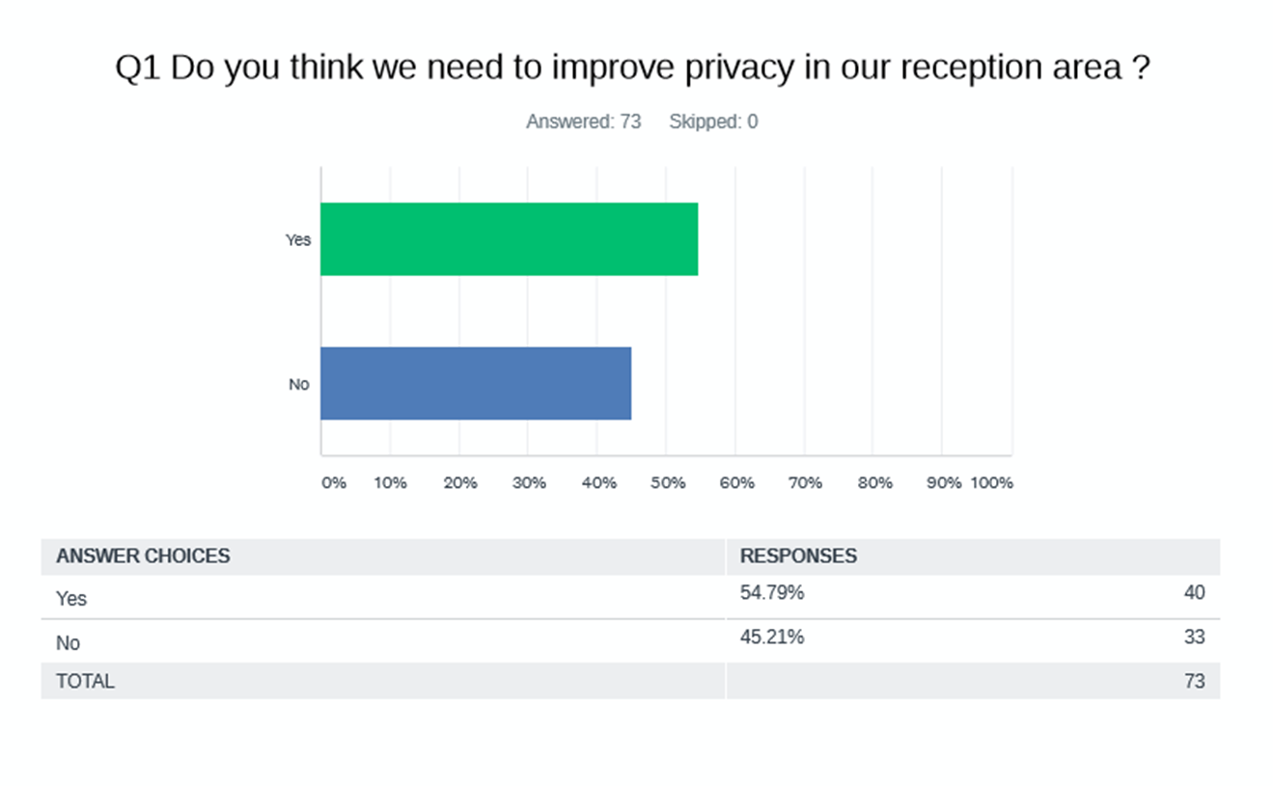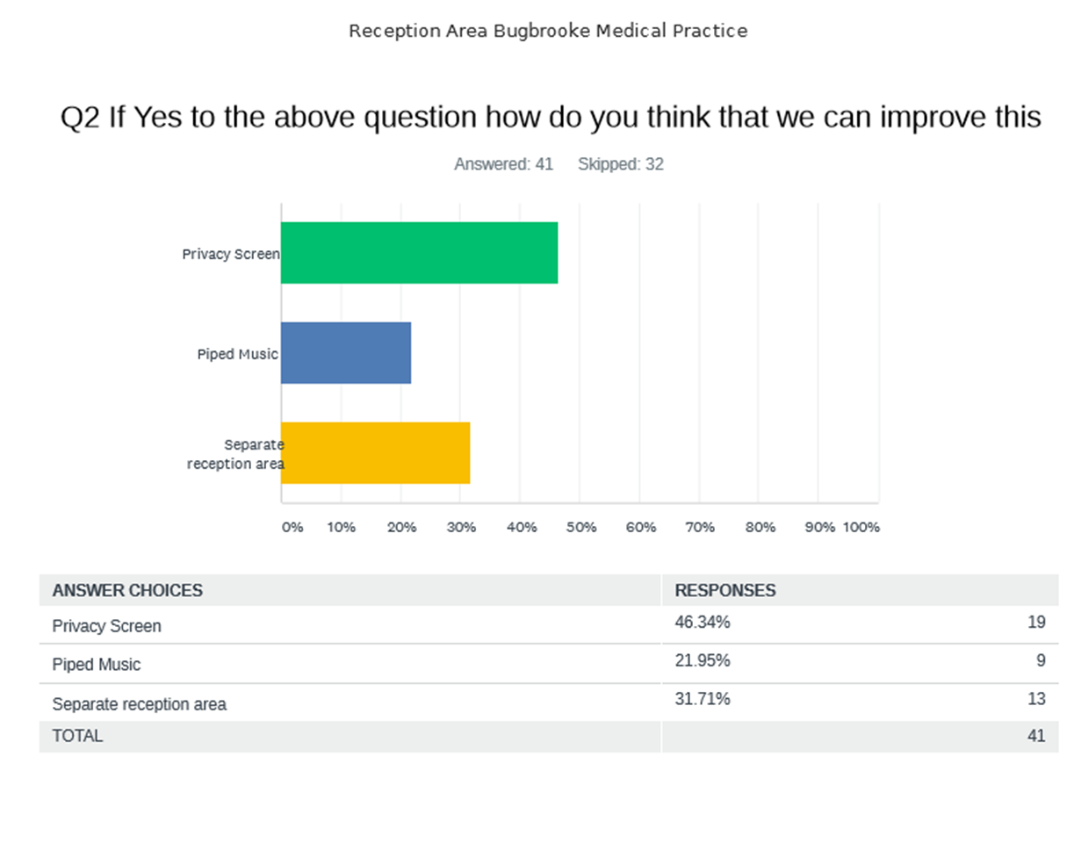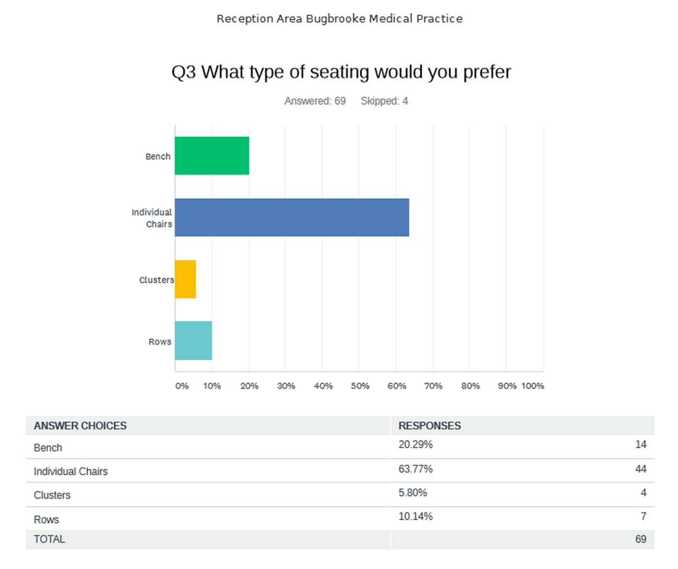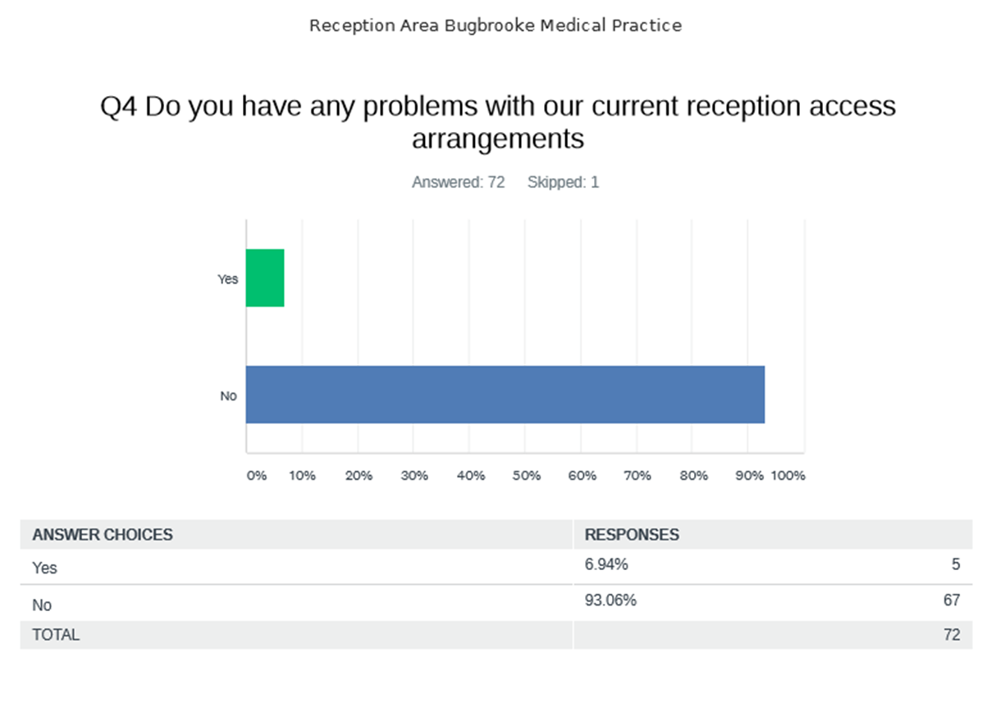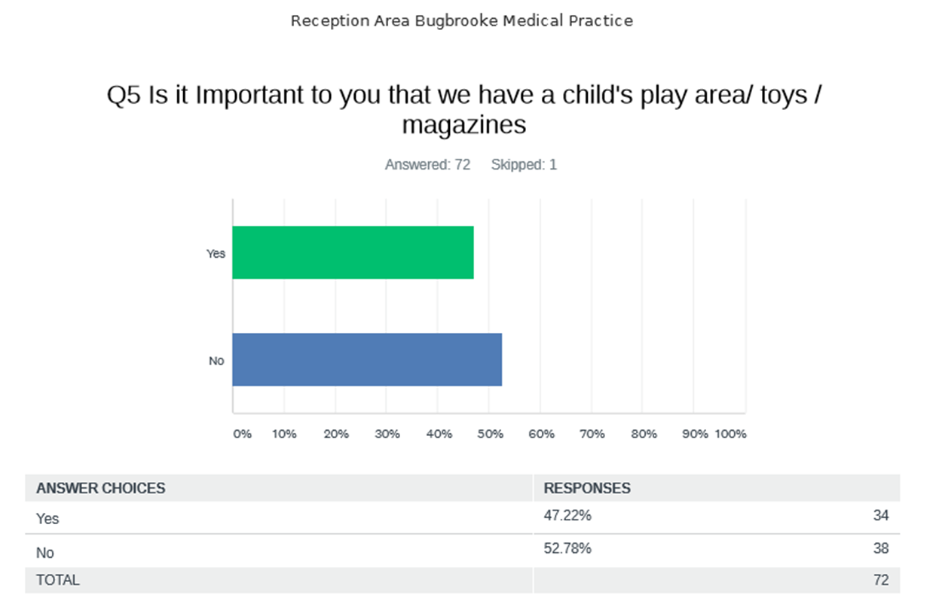
The current seating arrangements are fine, however when speaking to the receptionist, it would be nice to have the option of being able to have a more discreet conversation. A privacy screen and perhaps either piped music/radio station in the background would be ideal.
Nothing other than just a bit more privacy at the desk as everyone sat in the waiting area can hear the conversation that takes place between patient and receptionist. Rest of reception is clean, bright, spacious, comfortable. Possibly a few more individual supportive chairs that would be more comfortable for elderly patients than the benches.
For mundane and routine enquiries it is fine but not so good for more personal matters.
The reception and pharmacy queue should be at different points, at present they can merge.
No privacy due to the area reception is in and too near to pharmacy window.
Television.
Separate reception from seating area. Different chairs to accommodate the elderly and young children.
Better seating would be good.
I like it. Would be better if we didn’t have to wait, so appointments were more on time but I appreciate that is impossible. Maybe a brighter colour down the end where the toys and magazines are. Purple perhaps. Make it more homely and some pictures down that end rather than just information sheets.
The reception counter is too high, the reception team seem hidden. A clear safety screen to offer protection would be worthwhile but the counter should be lowered and the receptionists could sit higher in order for them to be available to offer assistance.
More privacy at the actual reception desk.
Another information screen at the back of the room. Other than that all is good.
A screen behind the person talking to receptionist to block the sound and piped music would be sufficient.
Your receptionists are lovely, but understandably under stress for some of the time. I do think less stress would mean a little bit of a more welcoming greeting and empathy. Only sometimes feel very much one of a number of a herd!!! – Hope this is taken in the spirit that is meant – Constructively.
Good as it is – maybe have both doors automatic?
Some background music would be good and more to look at on the existing screens.
Make the room screen clearer to see from the back current position makes it hard to see from back of waiting room.
Privacy regarding providing samples like urine samples onsite.
Perhaps replacing seating with chairs that can be wiped down regularly (plastic) to stop the spread of germs/Covid in the waiting area. My other suggestion re. privacy would be to be given a number on arrival for appointment & wait for your number to be called rather than names coming up on the screen for all to see, not that I find it a problem.
Lighter walls and floors. More modern and practical wipe over chairs and furniture. Screen dividers for reception staff and a quieter area for older patients or people with learning difficulties.
Just the privacy issue.
Coloured walls.
I don’t feel there is anything wrong with reception but do like monitors where they can be seen from every seat so you know when you have been called.
Update décor. The rest is absolutely fine.
Automatic doors for both accesses for ease and hygiene. Seating options spaced out and washable covering to seating.
None needed.
It is simply hard sometimes to chat at the reception desk about more personal things when the waiting room can probably hear – at least the people waiting behind you. A screen might help. The room is usually comfortable.
Ensure patients can talk confidentially to reception staff on arrival. Would also help if patients were allocated numbers rather than names being displayed on monitors.
Separate space for dropping off samples. Some plants would brighten the area.
More chairs for the elderly to help them stand up and sit comfortably.
The only problem I personally have is being able to see the tv screens, if I can’t sit by the big screen I can’t see the little one. And if it’s busy hearing the call can be hard too.
I think background music in the reception area would help to obscure patient’s confidential conversations with staff and maybe move the benches so that waiting patients are not sitting adjacent to reception or dispensary when you can’t help but listen to ongoing face to face conversations and those on the reception telephone.
Regarding children’s play area, could the items in the play area be a bit “quieter”. People who are sitting in the waiting area are obviously not feeling their best but have to listen to the racket made by children in the “play area”. I could understand having a play area if children have to wait hours but surely children can go without toys for 15 mins and give us all a bit of peace when we’re feeling unwell!? Thank you.
Privacy screen would help as not everyone stand back and waits when a patient is at the desk.
I personally find everything ok in reception.
Separated waiting area from reception desk.
Child area isn’t important to me but useful for parents of young children so believe it should be maintained. Currently it’s a functional space, no “need” to change it but maybe could look brighter with paintwork. Occasionally staff can be brusque; I personally prefer a more friendly informal approach – a smile goes a long way.
Second entrance door really difficult with pushchair. It there was a way to make the door electric wheelchairs and pushchairs would find it easier to get in.
Music or tv to occupy.
With a limited budget I think what you have is fine! The screen where you book in could be turned sideways so it’s more confidential. Also is there an option other that male or female on the check in screen as it would be quite a huge barrier if a patient was coming in to see you because of gender identity or struggles such as depression linked to this. It may well isolate them even more and prevent them feeling able to talk to the doctor and suicide rates are higher in this group. The receptionists are welcoming and a lot of what’s important in a reception isn’t down to money it’s down to feeling safe and welcome when people may be extremely anxious. When people have to give a urine sample do they have to carry it from the toilet to the reception? If yes this could be very uncomfortable for some people. Could they have a sealed bag with their name and date of birth on it and then have a place to put it/ post it in the bathroom area? Then it could be taken from there. Children’s toys are important, they need to associate the doctors with positive elements and not discomfort or pain. They also keep them occupied so it’s a quieter space for everyone.
Conversations are often difficult as person behind never adheres to the signs asking them to keep a distance. Often the questions that come from the receptionist are quite personal and this can make me feel uncomfortable with my answer.
Either a screen or music so that everyone is not listening to the dialogue. Nothing else .
When people are at the reception desk their conversation can be heard by everyone in the waiting room.
Separate reception desk from the pharmacy as people queueing are privy to confidential conversations.
Screen it off ideally to make it feel more private in terms of soundproofing for anyone asking a question or asking about results etc. Keep it see through though so the open plan feeling is maintained.
I think markers on the floor advising people to stand back would be sufficient / or an area that can be seen distinct and 1 patients at a time. More important things to spend budget on.
I think reception staff (not all) should always stand up to discuss with patient. Not ever talk from their desk across the dividing space which is not private at all.
I am very happy and have no issue with the current set up.
I think a privacy screen would work well.
It’s perfect.
Have a water dispenser for patients.
Redecorate.

